Test Case: runTestMultipleTimes
Step 1 - Enter username and password and click to button Enter : Credentials Entered
Image file-name: QC_Testing-runTestMultipleTimes-dic. 04 2025, 03 44 43 p. m.

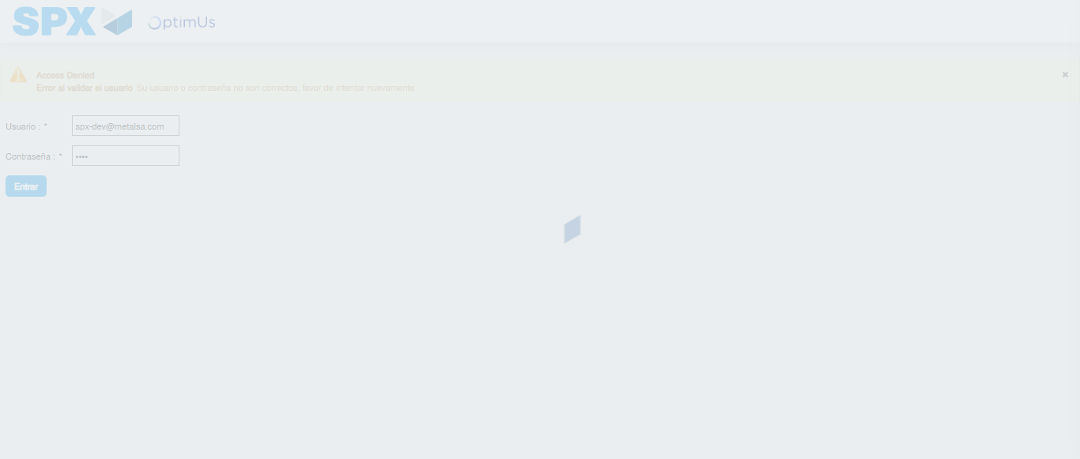Image file-name: QC_Testing-runTestMultipleTimes-dic. 04 2025, 03 44 44 p. m.

Step 2 - Select to UEN and Access to Spot Buy Requisitions : UEN Correctly selected and Correct access
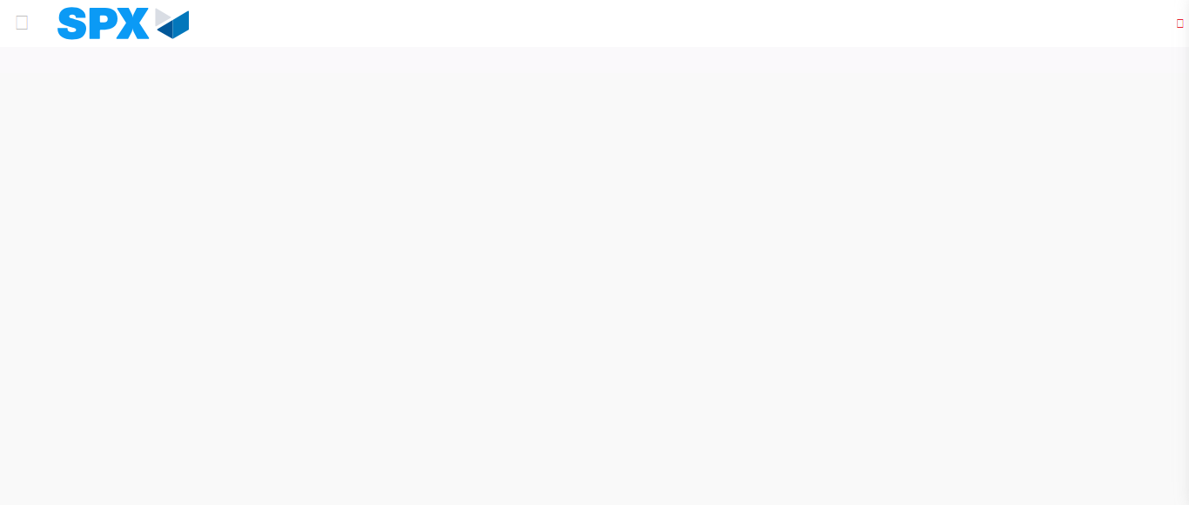Image file-name: QC_Testing-runTestMultipleTimes-dic. 04 2025, 03 44 53 p. m.

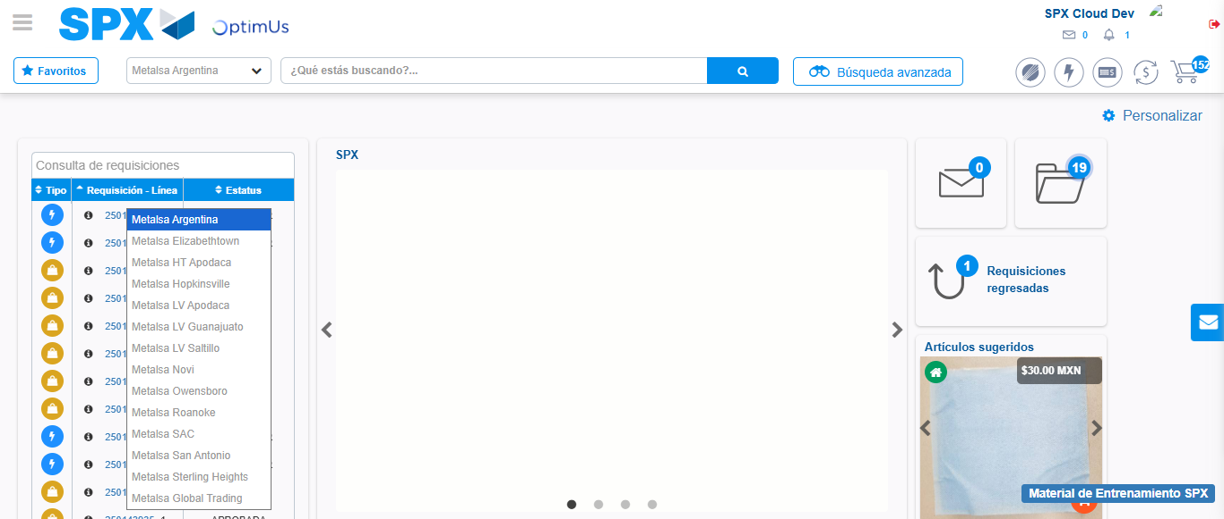Image file-name: QC_Testing-runTestMultipleTimes-dic. 04 2025, 03 44 54 p. m.

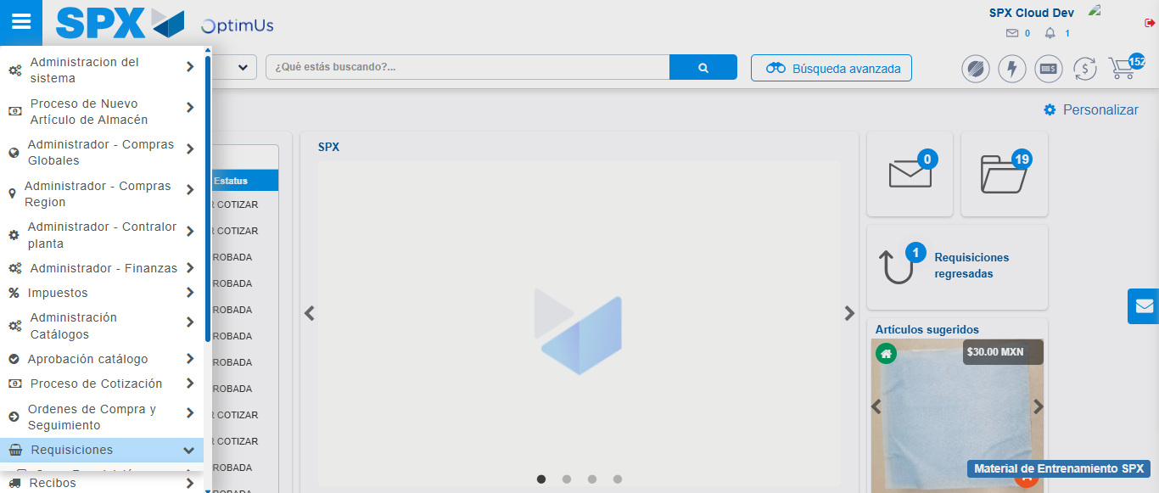Image file-name: QC_Testing-runTestMultipleTimes-dic. 04 2025, 03 44 55 p. m.

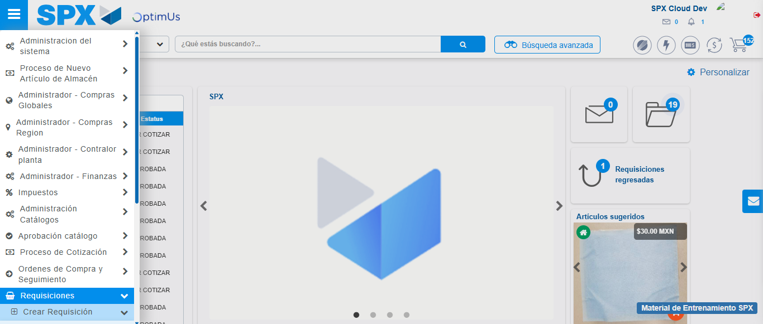Image file-name: QC_Testing-runTestMultipleTimes-dic. 04 2025, 03 44 56 p. m.

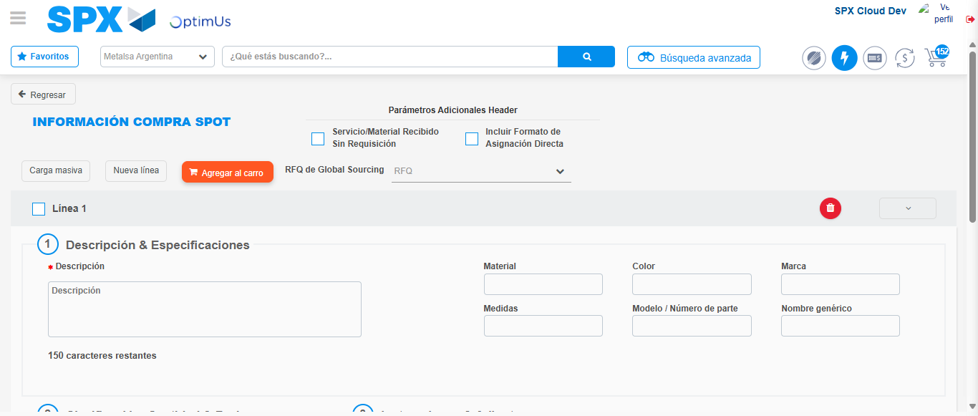Image file-name: QC_Testing-runTestMultipleTimes-dic. 04 2025, 03 45 02 p. m.

Step 3 - Add FAD to Requisition: FAD Successfully Added
Image file-name: QC_Testing-runTestMultipleTimes-dic. 04 2025, 03 45 02 p. m.

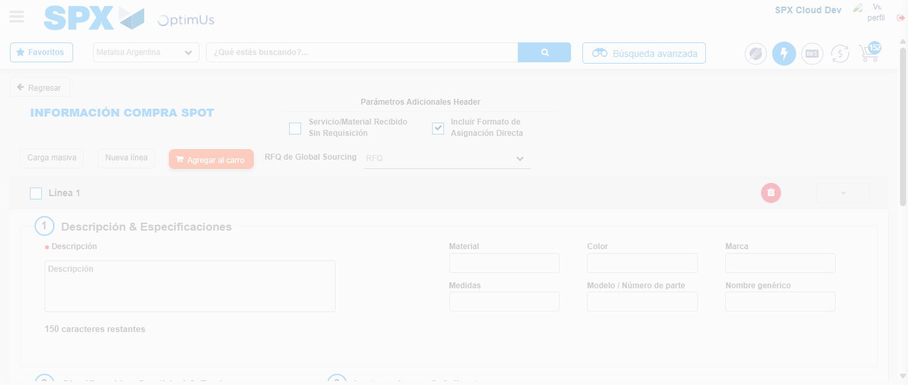Image file-name: QC_Testing-runTestMultipleTimes-dic. 04 2025, 03 45 03 p. m.

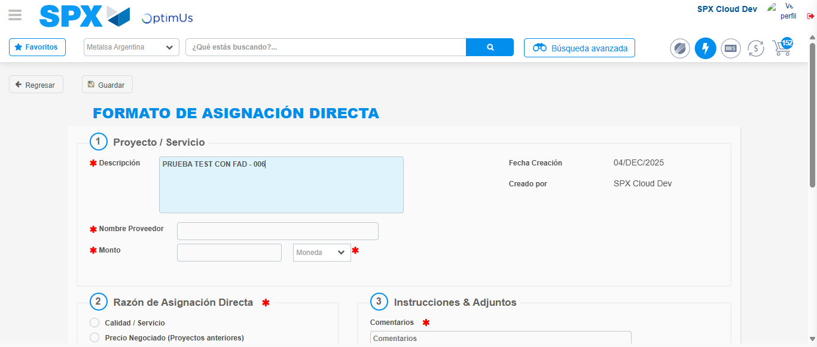Image file-name: QC_Testing-runTestMultipleTimes-dic. 04 2025, 03 45 06 p. m.

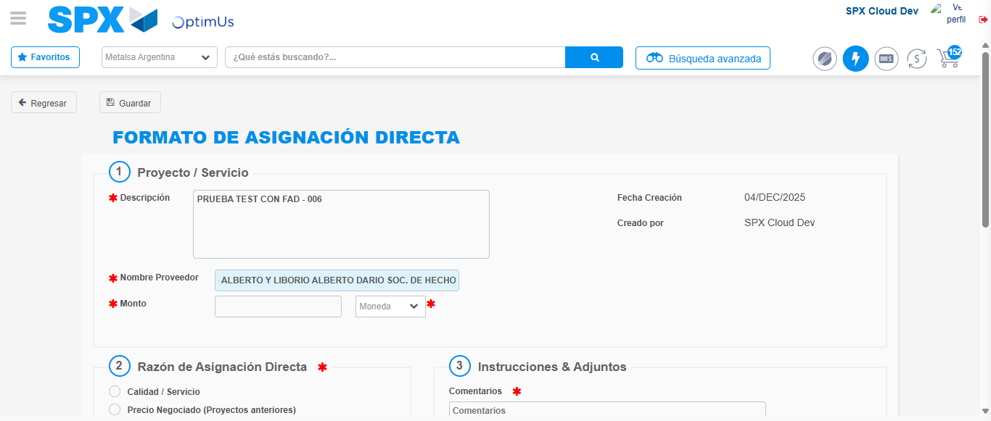Image file-name: QC_Testing-runTestMultipleTimes-dic. 04 2025, 03 45 07 p. m.

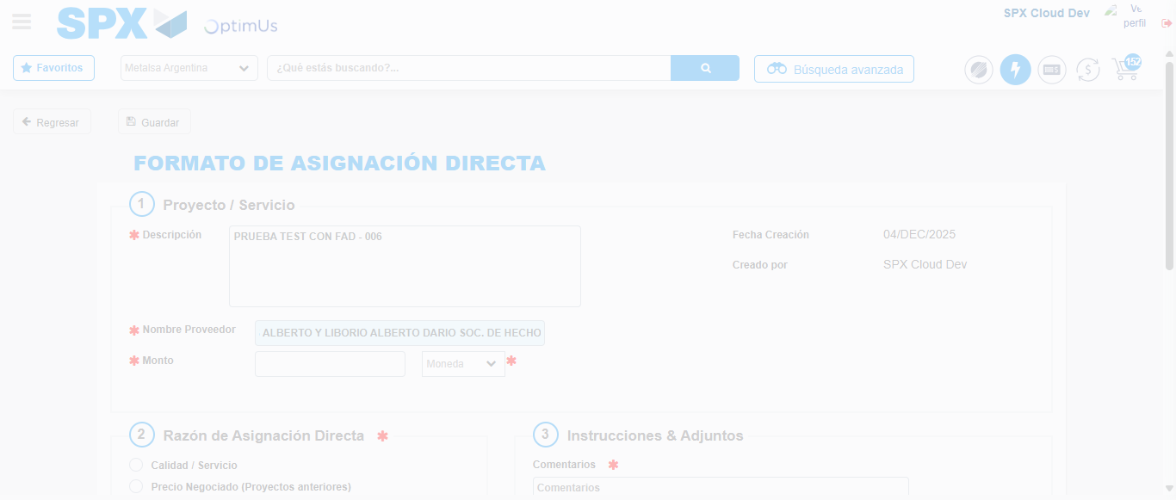Image file-name: QC_Testing-runTestMultipleTimes-dic. 04 2025, 03 45 10 p. m.

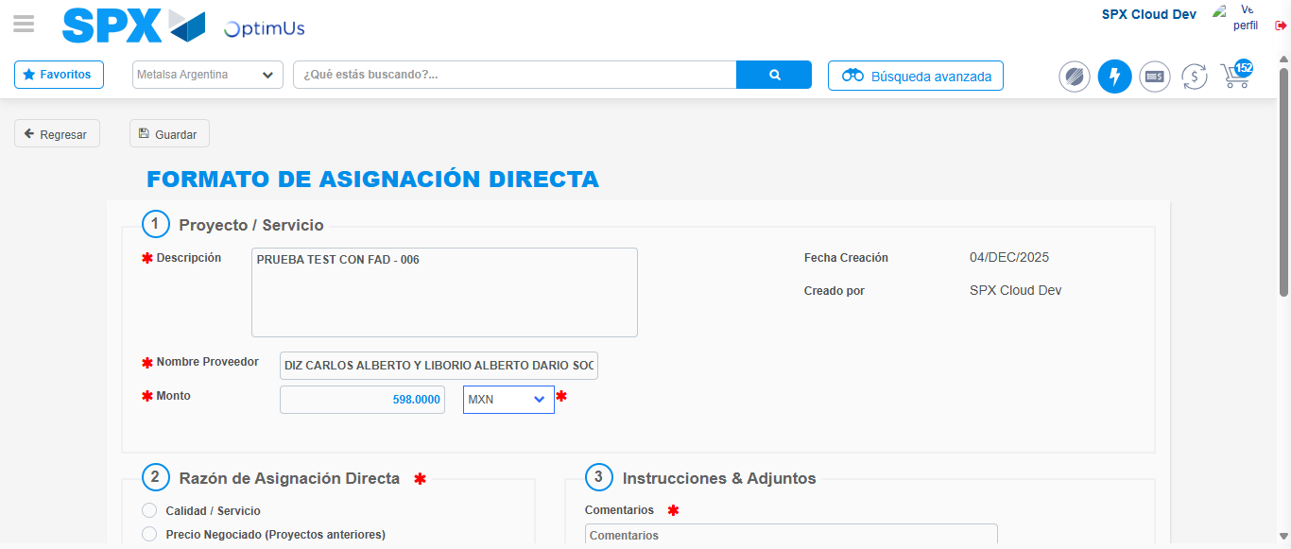Image file-name: QC_Testing-runTestMultipleTimes-dic. 04 2025, 03 45 14 p. m.

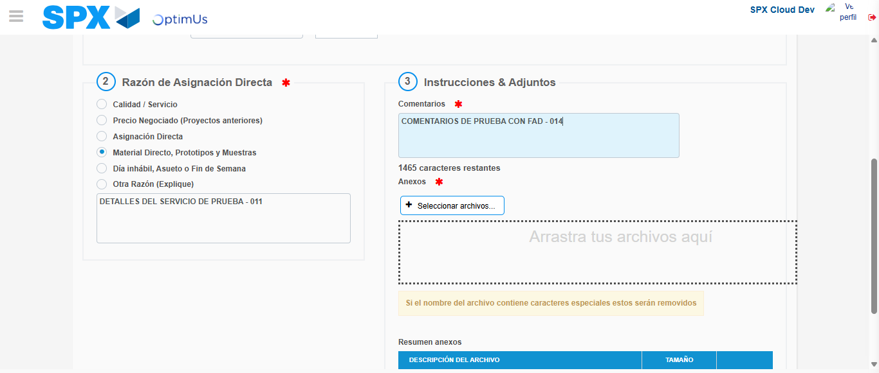Image file-name: QC_Testing-runTestMultipleTimes-dic. 04 2025, 03 45 18 p. m.

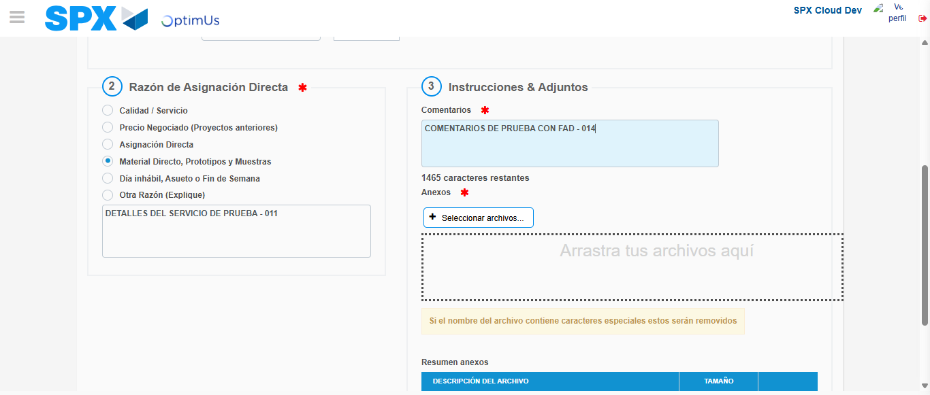Image file-name: QC_Testing-runTestMultipleTimes-dic. 04 2025, 03 45 21 p. m.

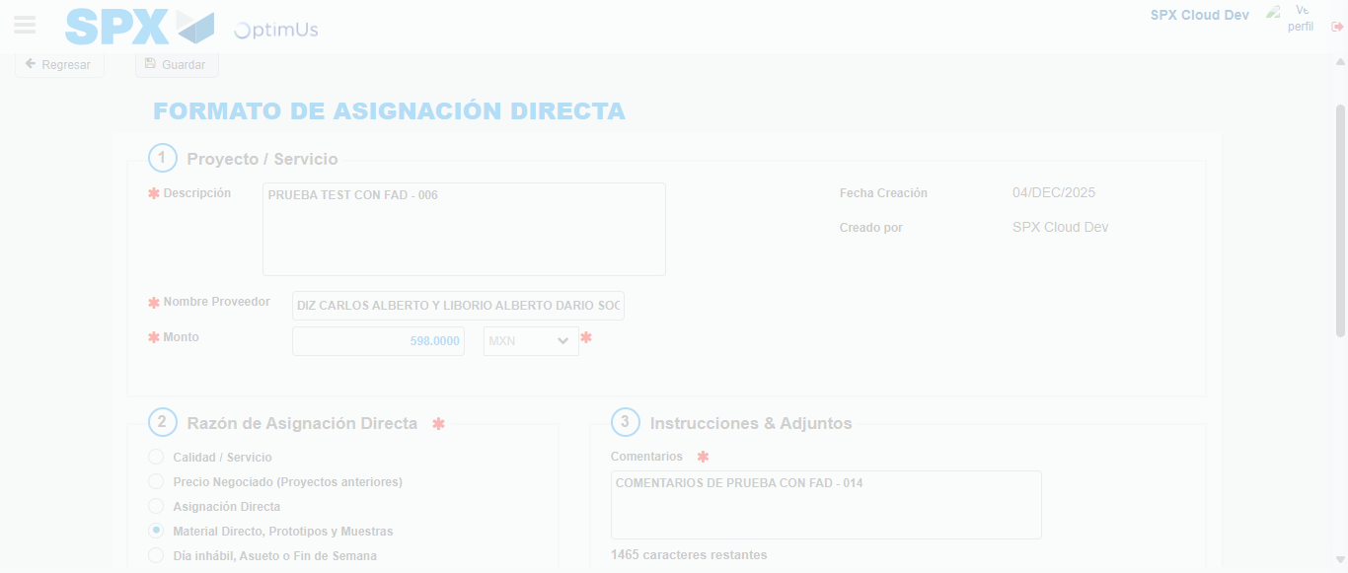Image file-name: QC_Testing-runTestMultipleTimes-dic. 04 2025, 03 45 22 p. m.

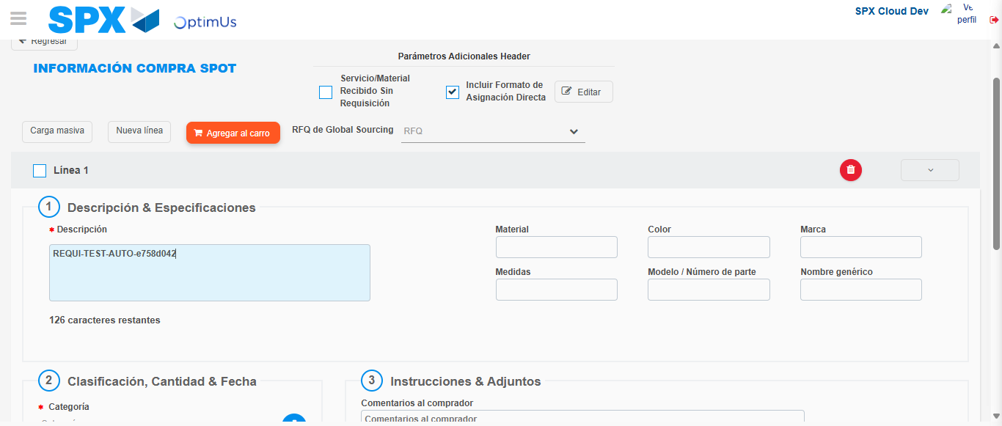Image file-name: QC_Testing-runTestMultipleTimes-dic. 04 2025, 03 45 25 p. m.

Step 4 - Data Capture Spot Buy Requisition: Data captured correctly
Image file-name: QC_Testing-runTestMultipleTimes-dic. 04 2025, 03 45 02 p. m.

Image file-name: QC_Testing-runTestMultipleTimes-dic. 04 2025, 03 45 03 p. m.

Image file-name: QC_Testing-runTestMultipleTimes-dic. 04 2025, 03 45 06 p. m.

Image file-name: QC_Testing-runTestMultipleTimes-dic. 04 2025, 03 45 25 p. m.

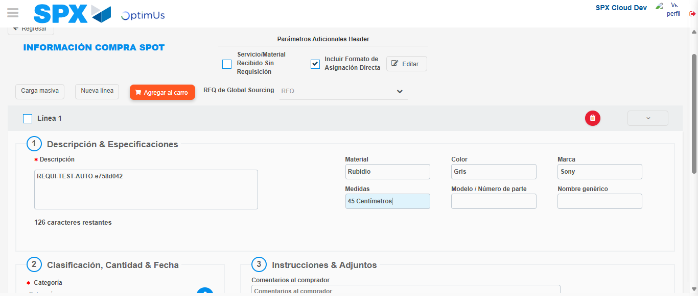Image file-name: QC_Testing-runTestMultipleTimes-dic. 04 2025, 03 45 26 p. m.

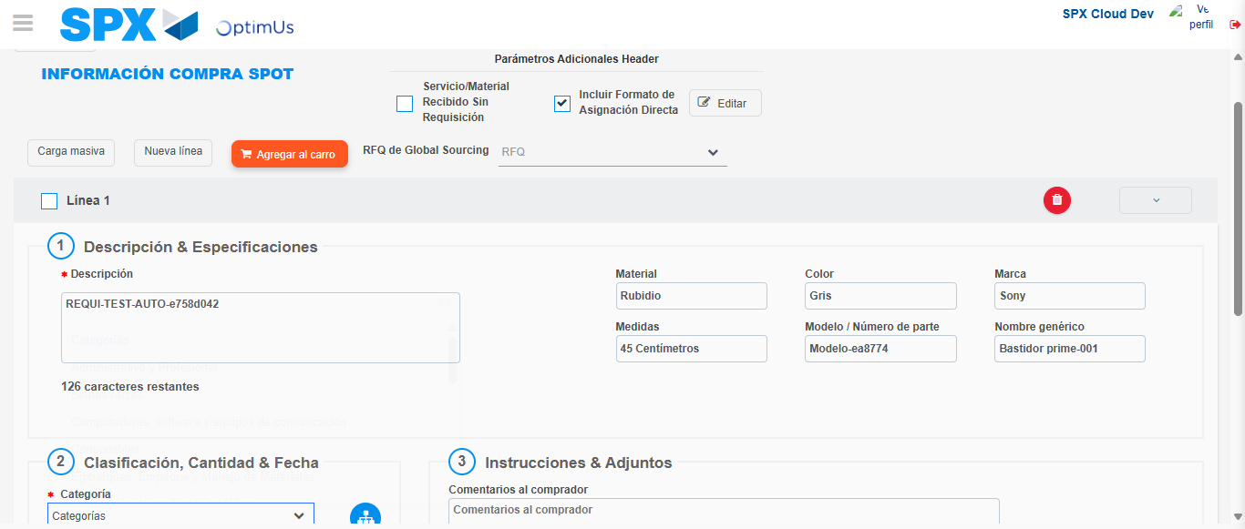Image file-name: QC_Testing-runTestMultipleTimes-dic. 04 2025, 03 45 27 p. m.

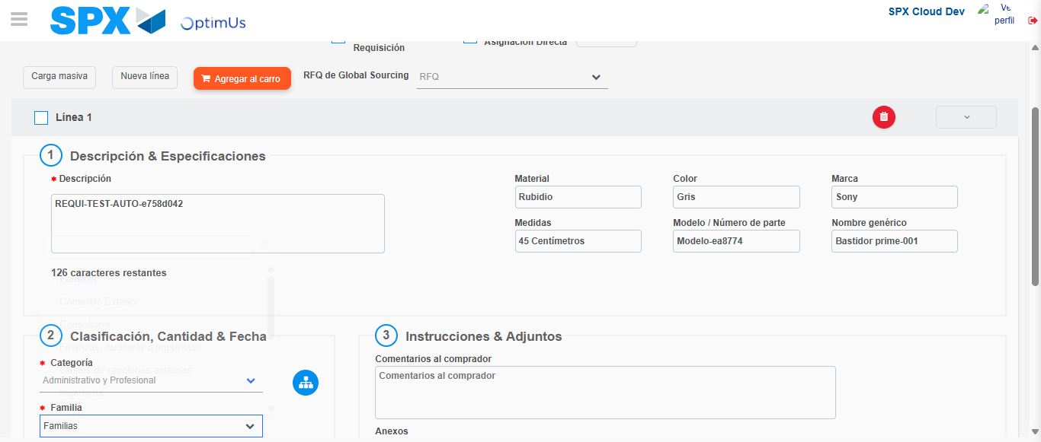Image file-name: QC_Testing-runTestMultipleTimes-dic. 04 2025, 03 45 28 p. m.

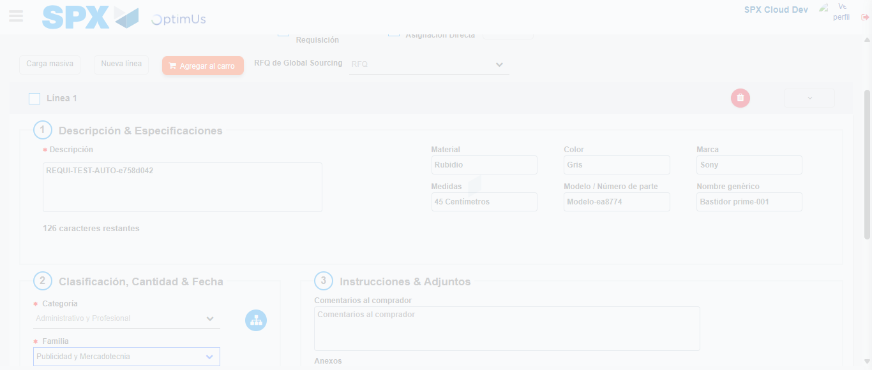Image file-name: QC_Testing-runTestMultipleTimes-dic. 04 2025, 03 45 29 p. m.

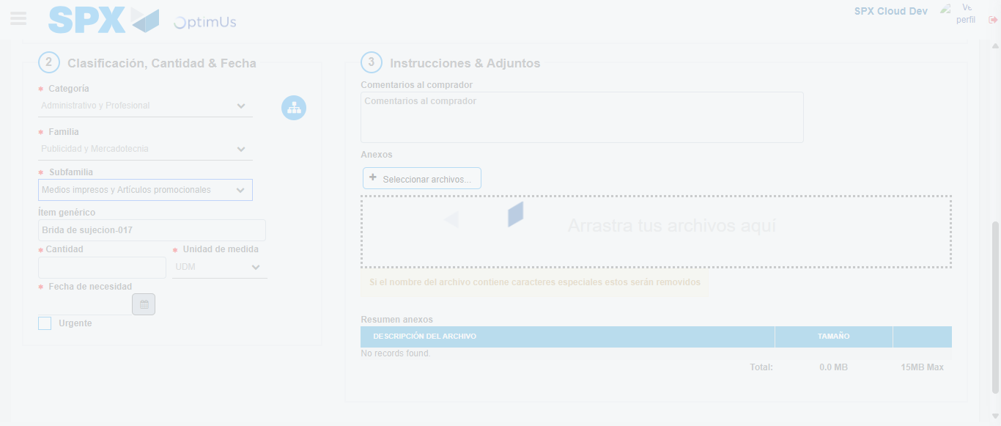Image file-name: QC_Testing-runTestMultipleTimes-dic. 04 2025, 03 45 30 p. m.

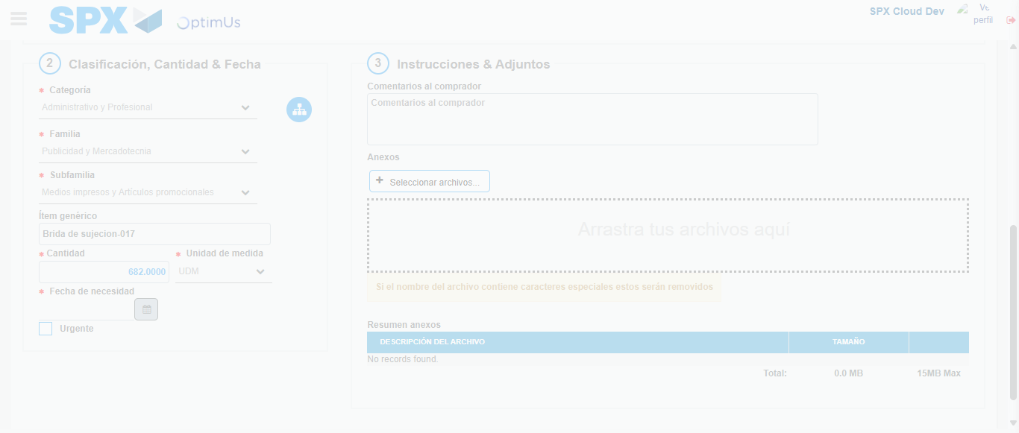Image file-name: QC_Testing-runTestMultipleTimes-dic. 04 2025, 03 45 31 p. m.

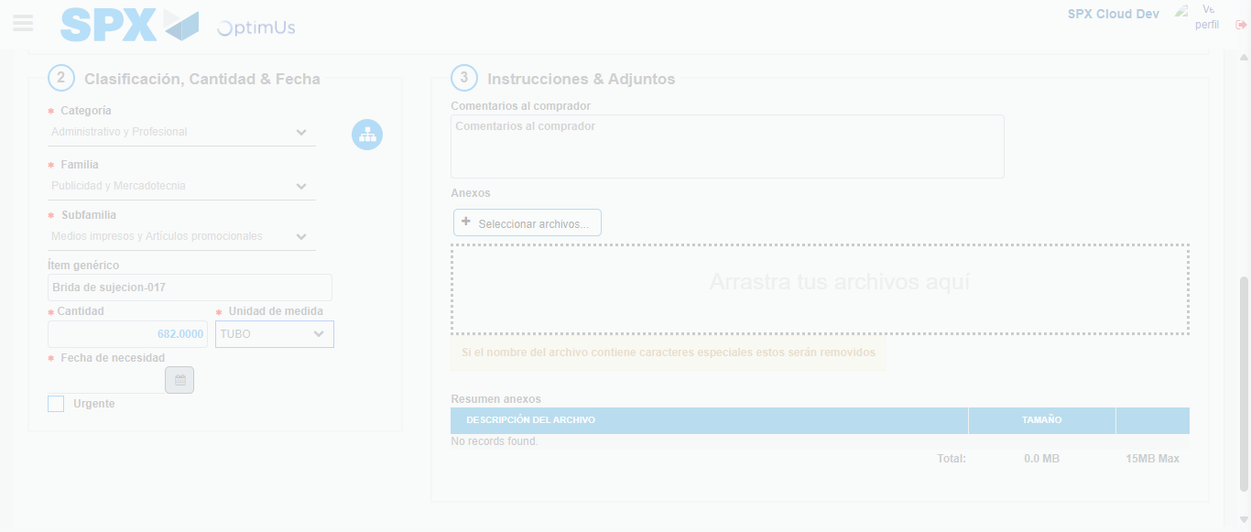Image file-name: QC_Testing-runTestMultipleTimes-dic. 04 2025, 03 45 32 p. m.

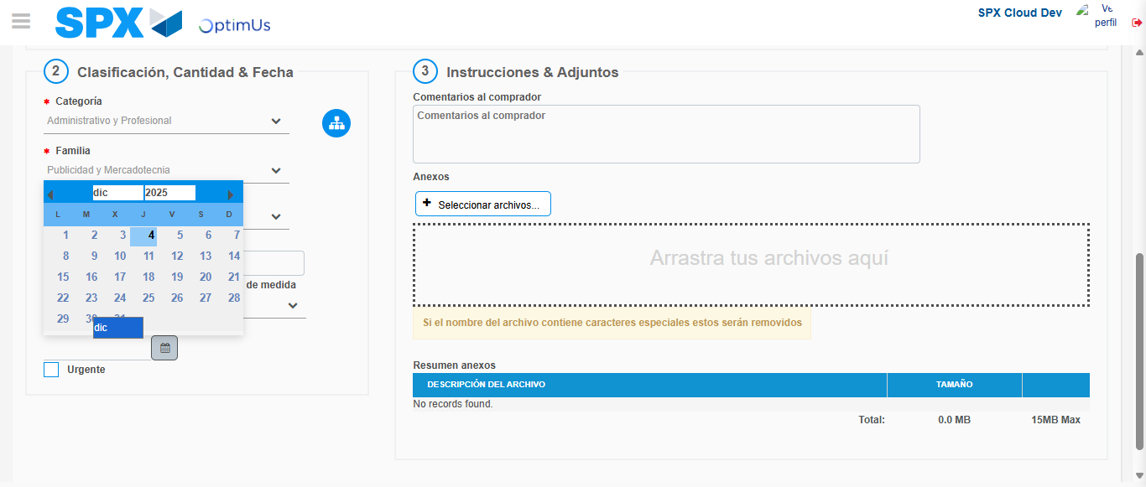Image file-name: QC_Testing-runTestMultipleTimes-dic. 04 2025, 03 45 33 p. m.

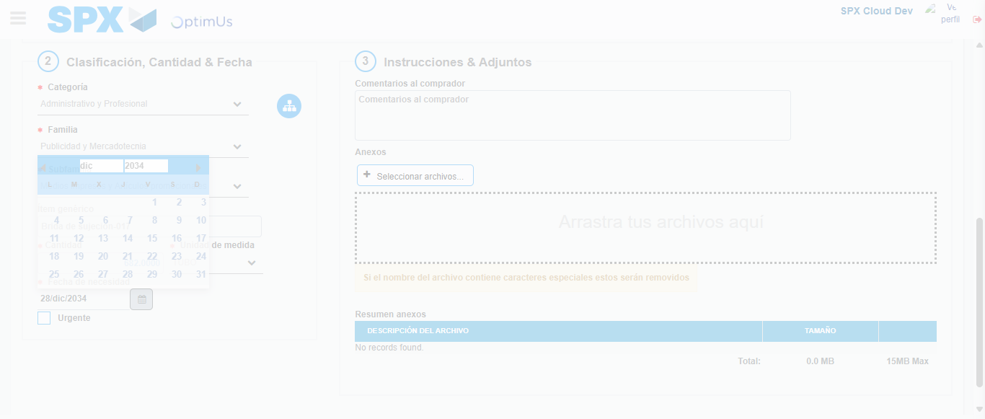Image file-name: QC_Testing-runTestMultipleTimes-dic. 04 2025, 03 45 34 p. m.

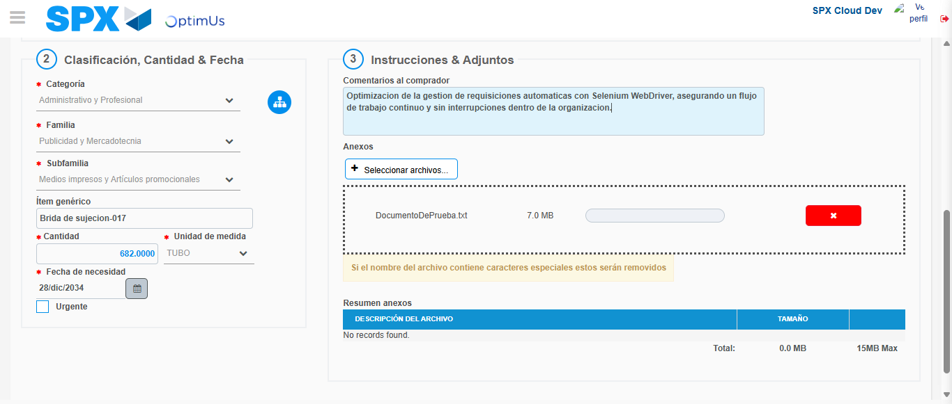Image file-name: QC_Testing-runTestMultipleTimes-dic. 04 2025, 03 45 35 p. m.

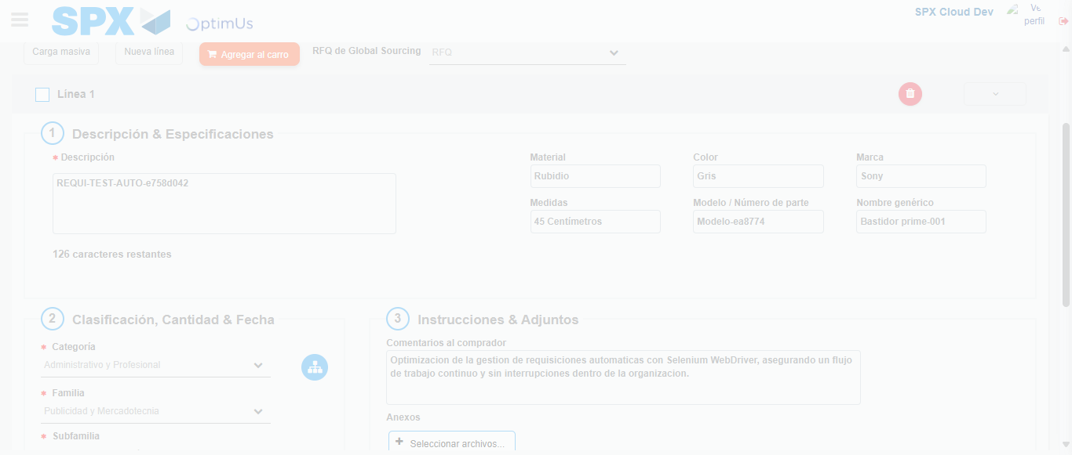Image file-name: QC_Testing-runTestMultipleTimes-dic. 04 2025, 03 45 36 p. m.

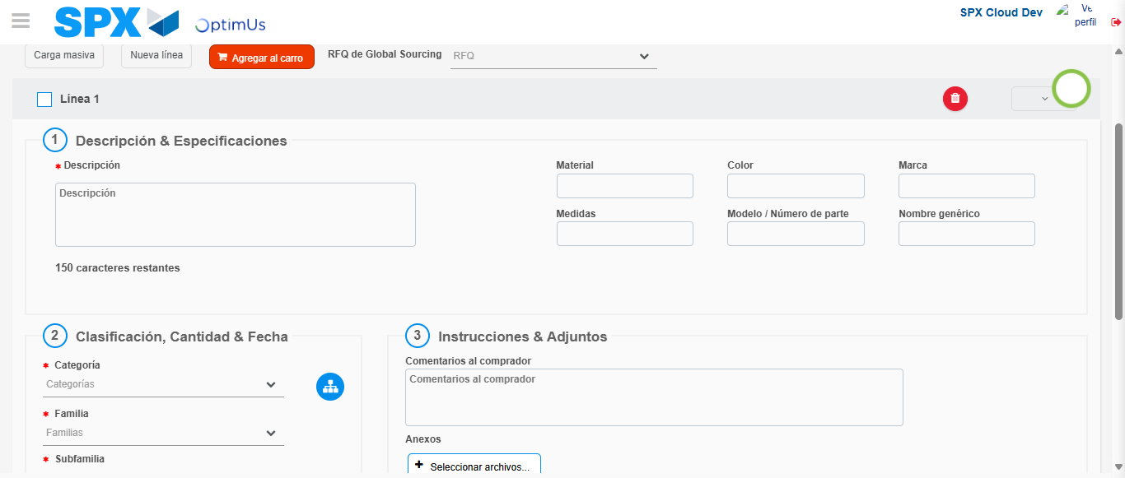Image file-name: QC_Testing-runTestMultipleTimes-dic. 04 2025, 03 45 46 p. m.

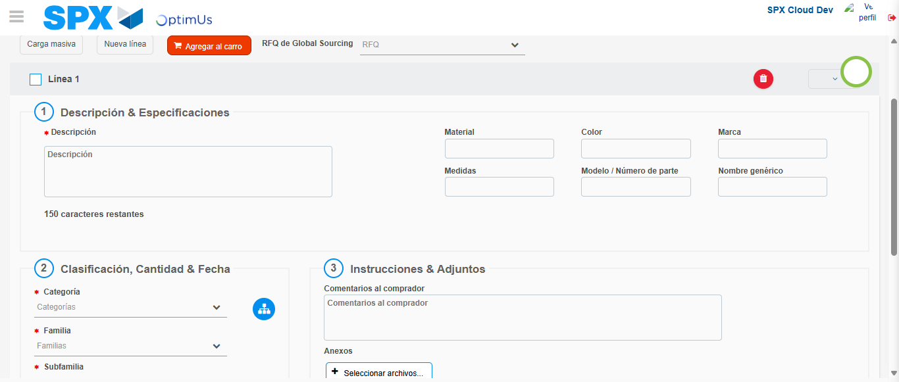Image file-name: QC_Testing-runTestMultipleTimes-dic. 04 2025, 03 45 47 p. m.

Step 5 - Select to Requisition: Requisition Correctly selected
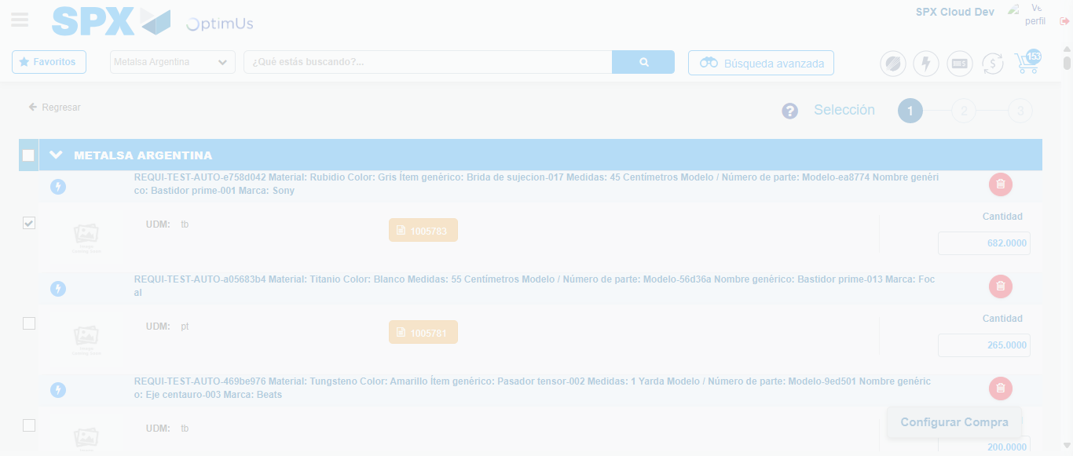Image file-name: QC_Testing-runTestMultipleTimes-dic. 04 2025, 03 45 58 p. m.

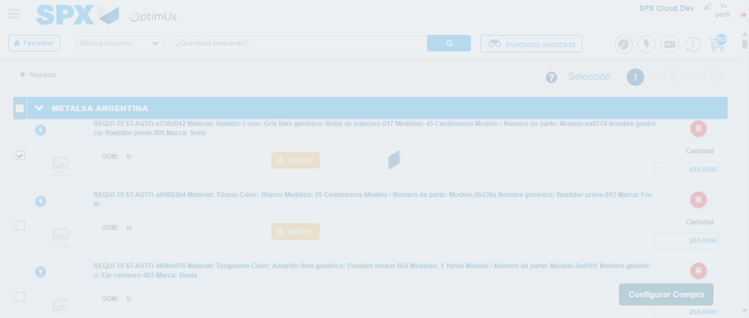Image file-name: QC_Testing-runTestMultipleTimes-dic. 04 2025, 03 46 02 p. m.

Step 6 - Select Type Account For Requisition: Type Account Correctly selected
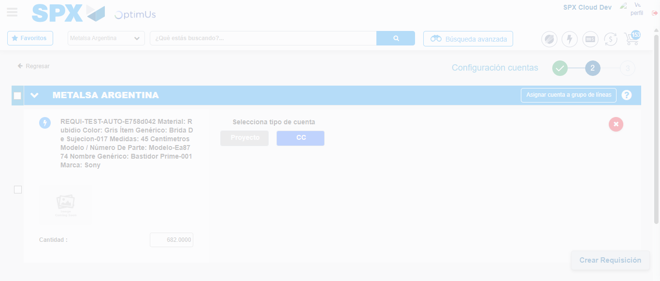Image file-name: QC_Testing-runTestMultipleTimes-dic. 04 2025, 03 46 05 p. m.

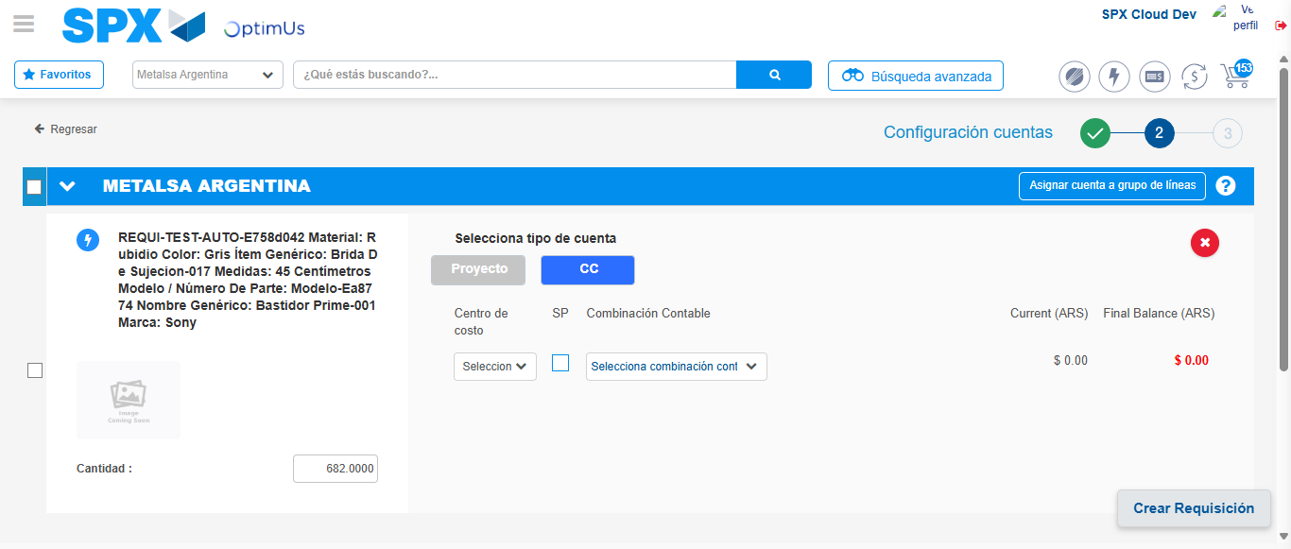Image file-name: QC_Testing-runTestMultipleTimes-dic. 04 2025, 03 46 09 p. m.

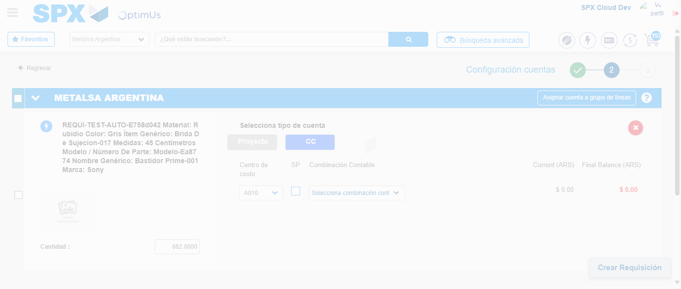Image file-name: QC_Testing-runTestMultipleTimes-dic. 04 2025, 03 46 12 p. m.

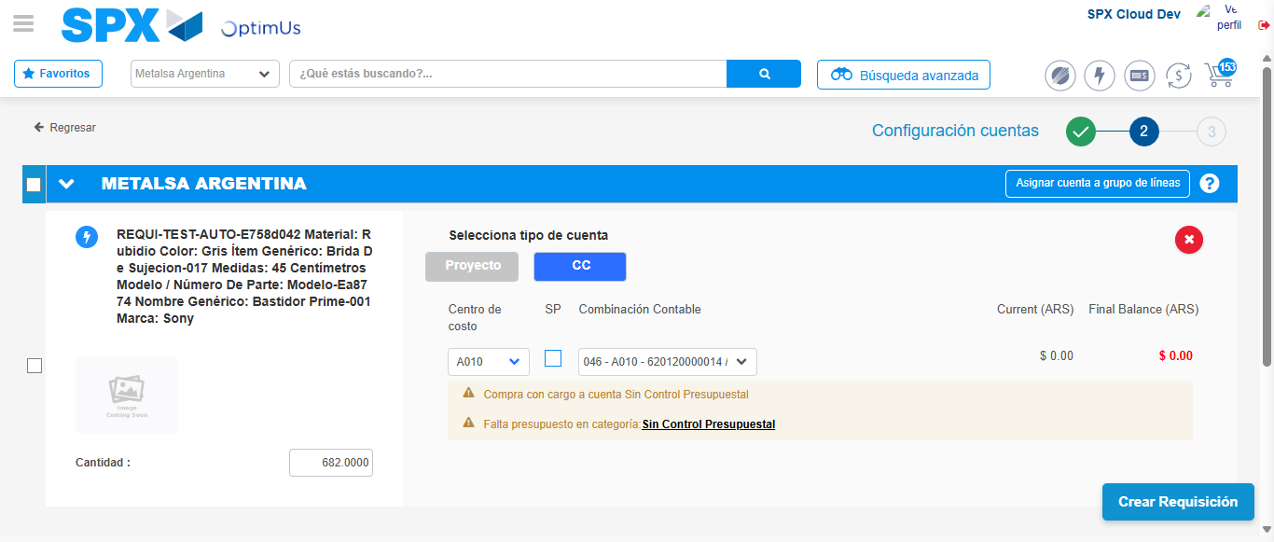Image file-name: QC_Testing-runTestMultipleTimes-dic. 04 2025, 03 46 15 p. m.

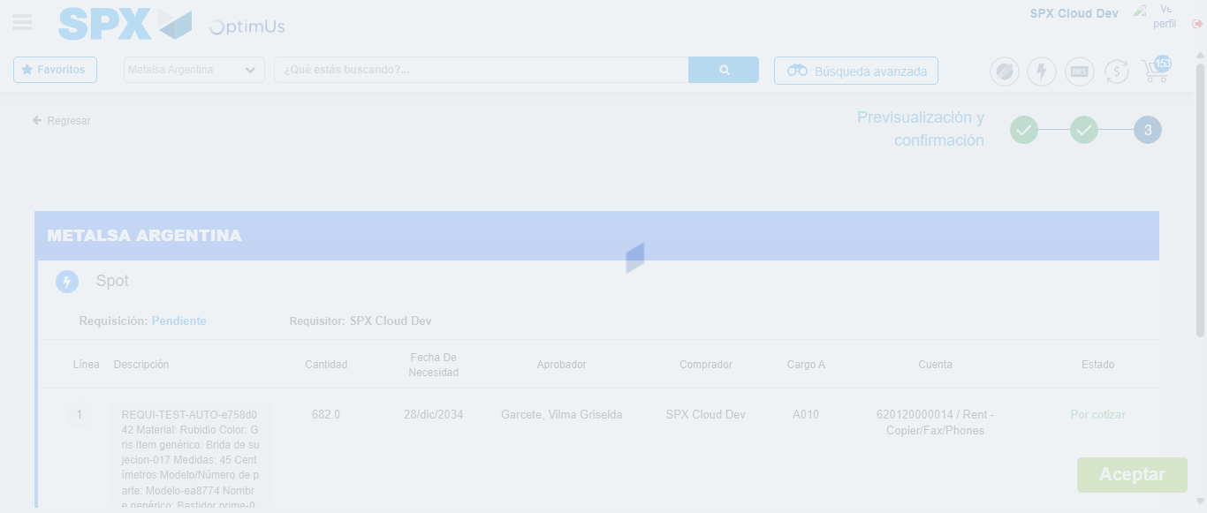Image file-name: QC_Testing-runTestMultipleTimes-dic. 04 2025, 03 46 16 p. m.

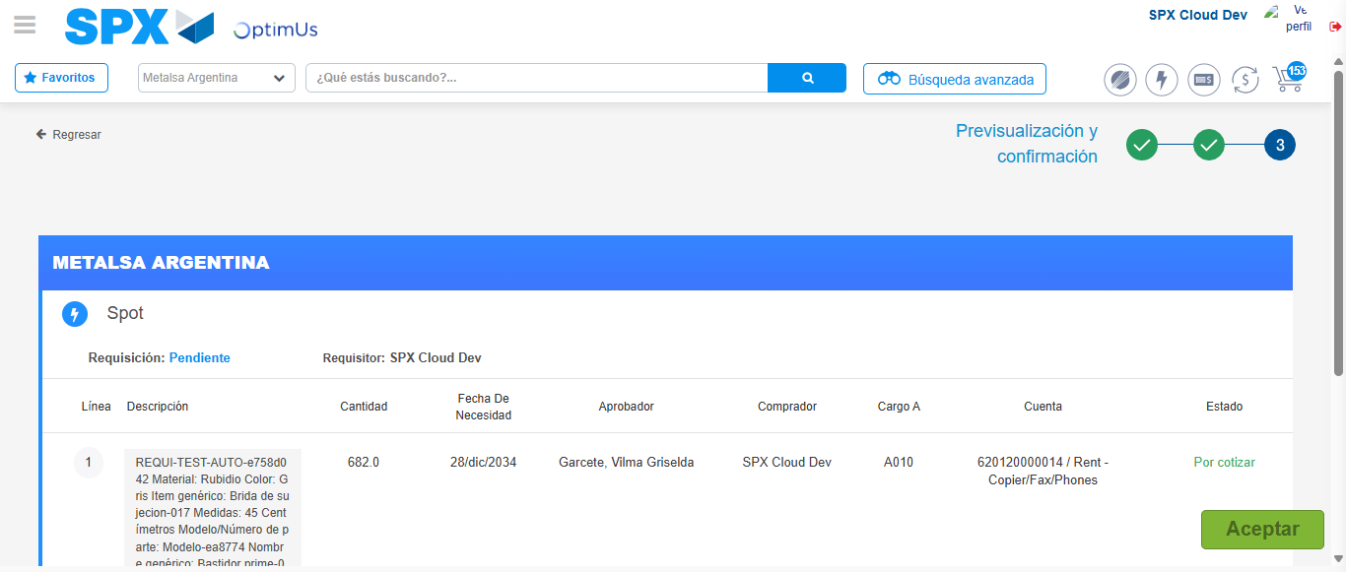Image file-name: QC_Testing-runTestMultipleTimes-dic. 04 2025, 03 46 19 p. m.

Step 7 - Accept to Requisition: Requisition Accepted
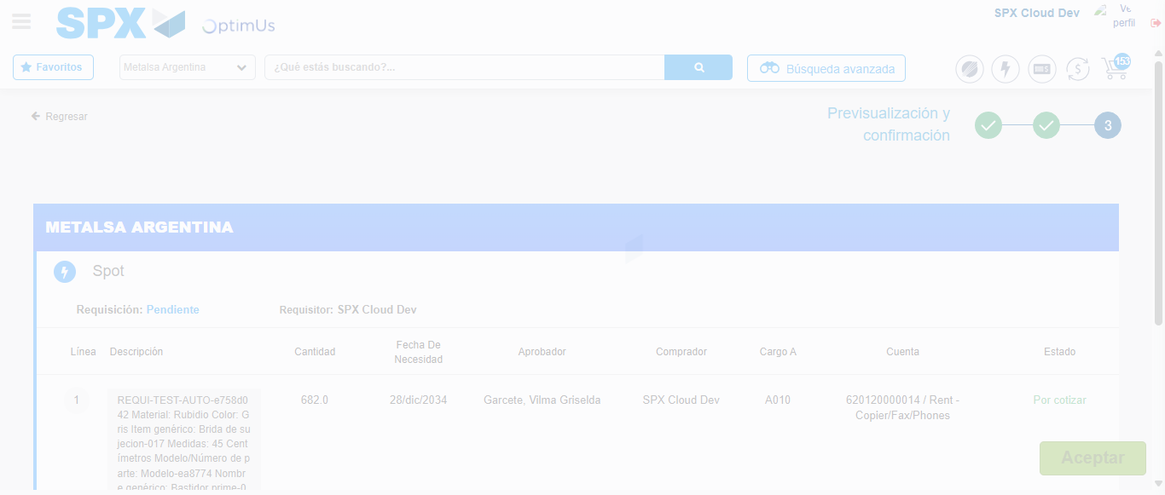Image file-name: QC_Testing-runTestMultipleTimes-dic. 04 2025, 03 46 20 p. m.

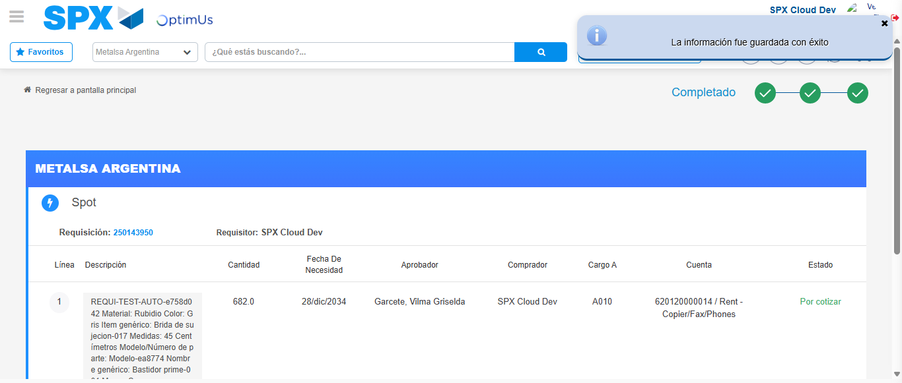Image file-name: QC_Testing-runTestMultipleTimes-dic. 04 2025, 03 46 23 p. m.

